

**Bachelor of Electrical and Electronic Engineering**

**EEE234 Electronics II Laboratory**

**Submitted to:** Md. Maidul Islam

Assistant Professor of Electrical and Electronic Engineering

Faculty of Engineering & Technology

**Submitted By:** Mirza Alamin Hossen

**ID:** 193400037

**Submission Form**

**Declaration**

We/ I declare that this material, which we/I now submit for assessment, is entirely our/my own work and has not been taken from the work of others, save and to the extent that such work has been cited and acknowledged within the text of my work. We/I understand that plagiarism, collusion, and copying are serious in the university and accept the penalties that would be imposed should we/I engage in plagiarism, collusion or copying.

**Student Signature:** 1)

**Date of Submission:** 08/01/2023

**Contents**

|  |  |  |
| --- | --- | --- |
| **Exp. No** | **Name of the Experiment** | **Page No** |
| 1 | Short brief about different Modern Tools used in EEE234 Laboratory course | 03 |
| 2 | Demonstration on Closed-loop Inverting and Non-inverting Amplifier  characteristics. | 07 |
| 3 | Demonstration on Physical Integrator and Differentiator Circuits | 18 |
| 4 | Demonstration on Closed-loop Summing Amplifier | 30 |
| 5 | Demonstration on Closed-loop Differential Amplifier | 35 |
| 6 | Demonstration on Low-Pass Filter Circuit | 40 |
| 7 | Demonstration on High-Pass Filter Circuits | 45 |

**Short brief about different Modern Tools used in EEE234 Laboratory course**

**Digital Multimeter:** A digital multimeter is a test tool used to measure two or more electrical values principally voltage (volts), current (amps) and resistance (ohms). It is a standard diagnostic tool for technicians in the electrical/electronic industries.

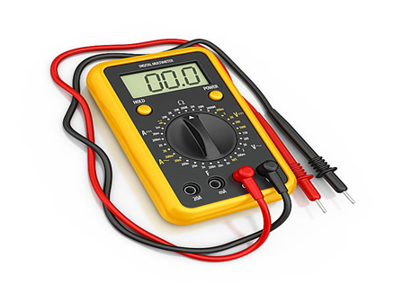

Figure-1: Digital Multimeter

**Oscilloscope:** An oscilloscope is an instrument that graphically displays electrical signals and shows how those signals change over time. Engineers use oscilloscopes to measure electrical phenomena and quickly test, verify, and debug their circuit designs.

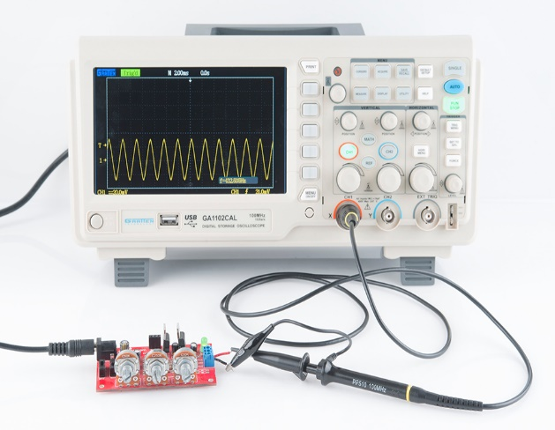

Figure-2: Oscilloscope

**Trainer board:** Conventional electronic trainer boards consist of breadboard as their main part for circuit connection and some other features such as LED display and switches.

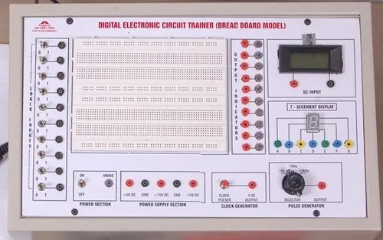

Figure-3: Trainer board

**Connecting wires:** A connecting wire is represented by a straight line. It is usually made of copper and is provided with insulation to make electrical connections between two points

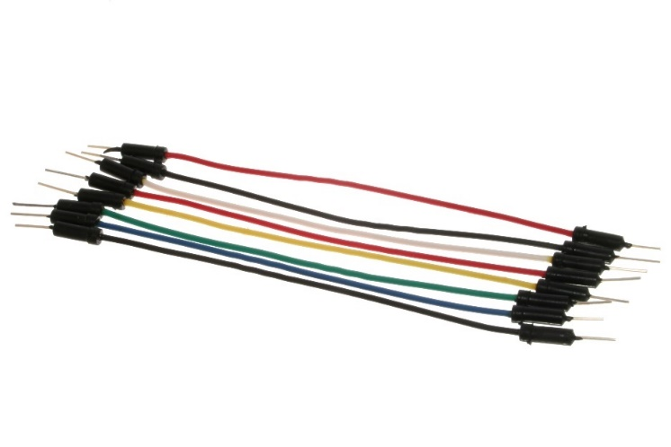

Figure-3: Connecting wires

**Op-amp IC(μA741):** The 741 Op Amp IC is a monolithic integrated circuit, comprising of a general-purpose Operational Amplifier. It was first manufactured by Fairchild semiconductors in the year 1963. The number 741 indicates that this operational amplifier IC has 7 functional pins, 4 pins capable of taking input and 1 output pin.

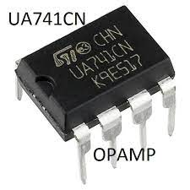

Figure-4: Op-amp IC(μA741)

**Resistors:** A resistor is an electrical component that limits or regulates the flow of electrical current in an electronic circuit. Resistors can also be used to provide a specific voltage for an active device such as a transistor.



Figure-5: Resistors

**DC Power supply:** A DC power supply provides direct current (DC) voltage to power a device under test such as a circuit board or electronic product.

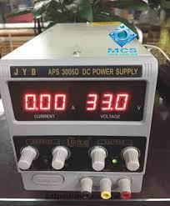

Figure-6: DC Power supply

**Capacitor:** A capacitor is a circuit component that temporarily stores electrical energy through distributing charged particles on (generally two) plates to create a potential difference. A capacitor can take a shorter time than a battery to charge up and it can release all the energy very quickly.

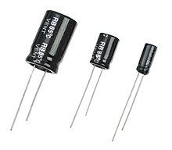

Figure-7:Capacitor

**Experiment no: 01**

## Name of the Experiments: Demonstration on Closed-loop Inverting and Non- inverting Amplifier characteristics.

**Objective:**

This experiment is intended to observe the application of Op-Amp IC as Inverting and Non- inverting Amplifier.

## Part-A: Inverting Amplifier

**Theory:** For close-loop inverting amplifier as shown in figure 1.1, the input voltage is applied to the inverting terminal of the op-amp and negative feedback is applied. The output voltage is feeding back to the inverting terminal of the op-amp via the feedback resistor, *RF*. The non- inverting terminal is grounded, and an extra resistor *R1* is connected in series with the input signal source *vin*. However, the difference input voltage is ideally zero; the voltage at the non- inverting terminal (*v2*) is approximately equal to that at the non-inverting terminal (*v1*). In other words, the inverting terminal voltage *v2* is approximately at ground potential. Therefore, the

inverting terminal is said to be at *virtual ground*. In the circuit of figure 1.1, *iin*  *iF*

*vin*  *v*2  *v*2  *vo*

that is,

*R*1 *RF*

However, *v*1  *v*2  0 V

Therefore,

*vin R*1

 *vo*

*RF*

or, *A*

 *vo*

 *RF*

*F v R*

*in* 1

The output voltage, *v*

 *A v*

 *RF v*

## Circuit Diagram:

*R*

*o F in in*

1

*iF*

*L*=*10k*



*iin*

*RF=2.2k* */3.3k*

*+12*

*2*

*R1=2.2k*

*v1*

*3*

*vid*

*v2*

*7*

***741***

*6 vo*

*vin*

*4*

*-12*

*R*

Figure-1.1: Inverting Amplifier

## Procedure:

* 1. Construct the circuit as shown in the figure-1.1
  2. Determine the values of different resistors and the gain AF.
  3. Calibrate the oscilloscope and take input signals from the signal generator and also adjust the amplitude and frequency.
     1. When *vin*(*dc*)=3V ,
        1. Determine the output voltage, *vo*
        2. Determine the output current, *Io* by applying Ohm’s Law.
        3. Calculate the theoretical output voltage, *vo*.
        4. Calculate the % of error for *vo* using the formula-

% of Error  *CalculatedValue* ~ *MeasuredValue* 100

*MeasuredValue*

* + 1. When *vin(ac)=3VPeak* at the frequency *of 1kHz.*
       1. Sketch *vo* and *vin* with respect to time.
       2. Determine the output current, *Io* by applying Ohm’s Law.
       3. Calculate the theoretical output voltage, *vo*
       4. Calculate the % of error.
  1. Measure the saturation time duration if saturations occur from the oscilloscope and also calculate the saturation time.
  2. Replace *RF* by another resistor of different value, and repeat the above instructions again and complete the data table- 1.1 given below.

**Part- B: Non-inverting Amplifier**

**Theory:** For close-loop non-inverting amplifier, the input voltage is applied to the non-inverting terminal of the op-amp and negative feedback is applied. The output voltage is feeding back to the inverting terminal of the op-amp via the feedback resistor, *RF*.

The difference voltage, *vid*

 *vo*

*A*

Since A is very large (ideally infinite), *vid*  0 that is *v*1  *v*2 (ideal)

Here, *v*1

 *vin*

and *v*2

 *vf*

 *R*1*vo*

*R*  *R*

1 *F*

And the gain with feedback, *A*  *vo*  1 *RF*

*F v R*

The output voltage, *v*  *A v*

*in* 1

 *A v*  (1 *RF* )*v*

*o F* 1

*R*

*F in in*

1

## Circuit Diagram:

*v =A v*



*RF=2.2k* */3.3k*

*+VCC*

*R1=2.2k* *v*

*id v1* ***741***

*3*

*v2*

*2*

*7*

*6*

*vin*

*4*

*-VEE*

*o F. in*

*RL*

Figure-1.2: Non-inverting amplifier with feedback gain *AF*.

## Procedure:

1. Construct the circuit as shown in the figure-1.2.
2. Determine the values of different resistors and the gain AF.
3. Calibrate the oscilloscope and take input signals from the signal generator and also adjust the amplitude and frequency.
   1. When *vin*(*dc*)=3V ,
      1. Determine the output voltage, *vo*
      2. Determine the output current, *Io* by applying Ohm’s Law.
      3. Calculate the theoretical output voltage, *vo*.
      4. Calculate the % of error for *vo* using the formula

% of error  *CalculatedValue* ~ *MeasuredValue* 100

*MeasuredValue*

* 1. When *vin(ac)=3VPeak at the frequency of 500 Hz.*
     1. Sketch *vo* and *vin* with respect to time.
     2. Determine the output current, *Io* by applying Ohm’s Law.
     3. Calculate the theoretical output voltage, *vo*
     4. Calculate the % of error for *vo*.

1. Measure the saturation time duration if saturations occur from the oscilloscope and also calculate the saturation time.
2. Replace *RF* by another resistor of different value, and repeat the above instructions again and complete the data table-1.2 given below.

**Results:**

**Theoretical Calculation, Data Table, Figure:**

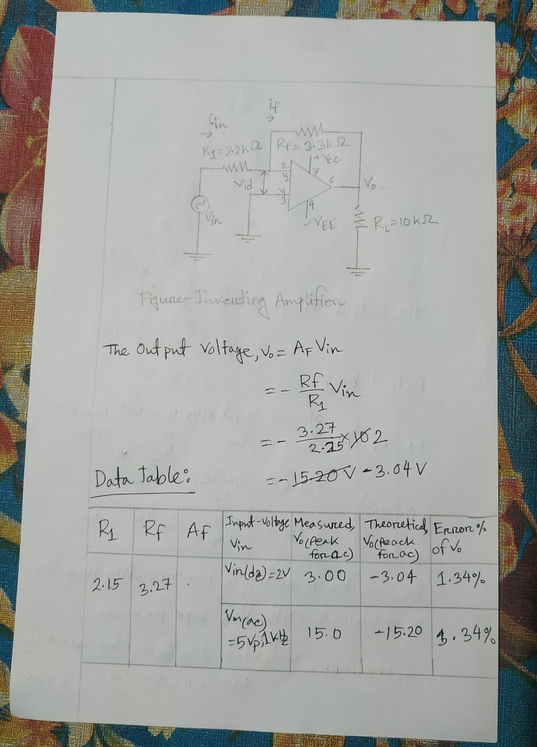

**Figure-1: Inverting Amplifier**

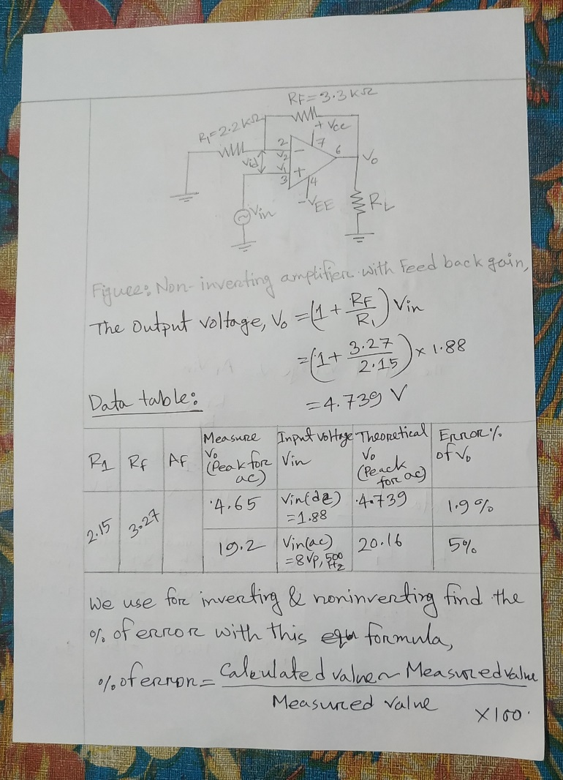

**Figure-2: Non-inverting Amplifier**

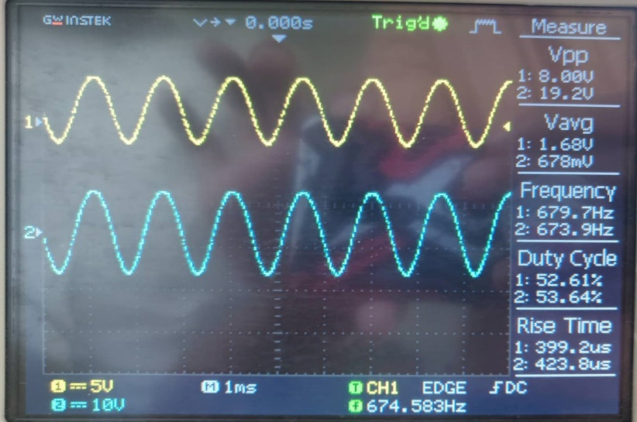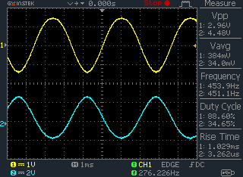

**Figure-03: Non-inverting Amplifier Output wave Figure-04: Inverting Amplifier Output wave**

**Answer-01**

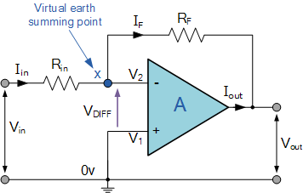

In this **Inverting Amplifier** circuit, the operational amplifier is connected with feedback to produce a closed loop operation.  When dealing with operational amplifiers there are two very important rules to remember about inverting amplifiers, these are:

* No Current Flows into the Input Terminals
* The Differential Input Voltage is Zero as V1 = V2 = 0 (Virtual Earth)

Current (i) flows through the resistor network as shown.

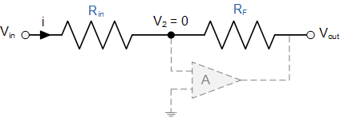

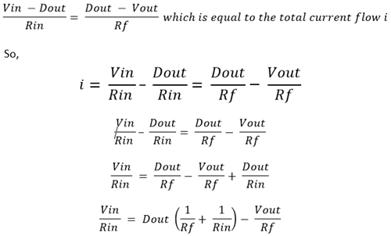

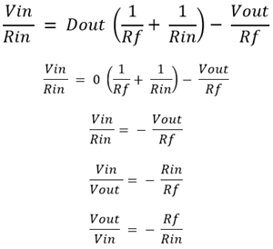

So, the **inverting amplifier formula** for closed loop gain will be.

### 

### Non-inverting Operational Amplifier Configuration:

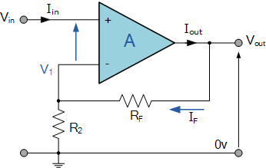

**Non-inverting Operational Amplifier Gain**

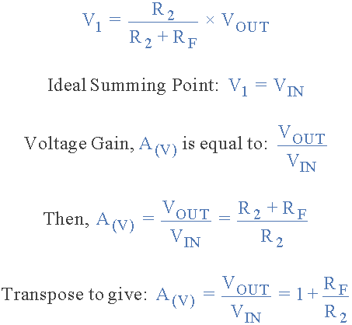

**Answer-02**

The closed-loop voltage gain of the non-inverting amplifier is AV is given as **(1 + R /R)**. If we make this equal to 2 through making R = R, then the Vout becomes equal to the addition of all the input voltages.

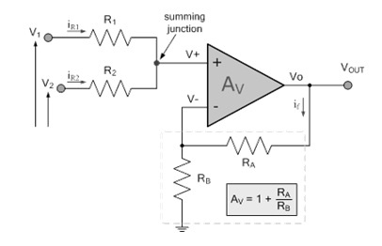

**Answer-03**

Amplifier circuit for the input and output wave-shape-

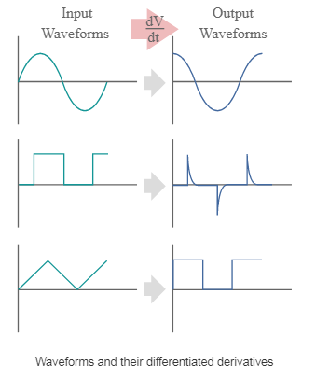

**Discussion:**

An inverting op amp is an operational amplifier circuit with an output voltage that changes in the opposite direction as the input voltage. A non-inverting op amp is an operational amplifier circuit with an output voltage that is in phase with the input voltage. A non-inverting amplifier produces an output signal that is in phase with the input signal, whereas an inverting amplifier’s output is out of phase. Both the inverting and non-inverting op amps can be constructed from one op amp and two resistors, just in different configurations.

In this experiment, we learn how to analyzed closed loop inverting and non-inverting amplifier using op-amp µ-741 IC. A µ-741 IC connected inverting and non-inverting amplifier. We had done all step by following procedure. I performed an experiment by using an Op-Amp IC and resistor and connect a DC/AC power supply to the circuit and verify both the Inverting and Non-inverting Amplifier conditions of the Op-Amp IC and got the desired result. Then all is perfect we collect result for data table.

**Experiment no: 02**

## Name of the Experiments: Demonstration on Physical Integrator and Differentiator Circuits.

**Objective:**

To exhibit the output wave shapes of physical Integrator and Differentiator Circuits at different input signal.

## Theory:

**Integrator:** A circuit in which the output voltage waveform is the integral of the input voltage waveform is the integrator or the integration amplifier. Such a circuit is obtained by using a basic inverting amplifier configuration if the feedback resistor RF is replaced by a capacitor CF.

*vin*

*I1*

*R1*



*I*

*B*

*IF*

*v2*

*2*

*CF*

*+12V*

*7*

*6* 1 *t*

*vid A*

*v*

*1 3*

*vo*   *RC* *vindt*  *c*

*Rom*

*4*

*-12V*

1 *F* 0

*RL*

**Figure 2.1: The integrator circuit**

Applying Kirchhoff’s current equation at node *v2* **:** *i*1  *IB*  *iF* Since IB is negligibly small, *i*1  *iF*

The current through the capacitor, *i*  *i*

 *C dvc*

Therefore,

*vin*  *v*2  *C*

*d* (*v*

*c F dt*

* *v* )

*R F dt* 2 *o*

1

However, *v*  *v*

 0 since *A* is very large. Therefore,

*vin*  *C*

*d* (*v* )

1 2 *F dt o*

*R*

1

The output voltage can be obtained by integrating both sides with respect to time:

*t v t d*

⇩

*in dt* 

*R*

*CF*

*dt* (*vo*

)*dt*

0 1 0

1 *t*

⇒ *vo*   *RC*  *vindt*  *c*

1 *F* 0

## Differentiator:

Figure 2.2 shows the *differentiator* or *differentiator amplifier.* As its name implies, the circuit performs the mathematical operation of differentiator; that is, the output waveform is the derivative of the input waveform. The differentiator may be constructed from a basic inverting amplifier if an input resistor *R1* is replaced by a capacitor *C1*.

*vin*

*I1*

*C1*



*I*

*B*

*IF*

*v2*

*v 2 A*

*RF*

*+12 V*

*7*

*6 v*

 *R C d v*

*v1 id 3*

*4*

*-12 V*

*o F* 1 *dt in*

*RL*

*Rom*

**Figure 2.2: Basic differentiator circuit**

Applying Kirchhoff’s current equation at node *v2* **:** *i*1  *IB*  *iF* Since IB is negligibly small, *i*1  *iF*

The current through the capacitor, *i*

 *i*  *C*

*dvc*  *C*

*d* (*vin*  *v*2 )

*C*1

*d* (*vin*  *v*2 )  *v*2  *vo dt RF*

*c* 1 1 *dt*

1 *dt*

However, *v*1  *v*2  0 because A is very large. Therefore,

*C dvin*  *vo*

1

*dt RF*

⇒ *v*  *R C*

*dvin*

*o F* 1 *dt*

Thus the output *vo* is equal to *RFC1* times the negative instantaneous rate of change of the input voltage *vin* with time. Since the differentiator performs the reverse of the integrator’s function, a cosine wave input will produce a sine wave output, or a triangular input will produce a square wave output and a square wave input will produce some impulse.

## Circuit Diagram for experiment:

*vin*

*I1*

*R1=1 k*



*IB*

*IF*

*CF=0.1**F*

*+12V*

*v2 7*

*2 6* 1 *t*

*vid*

*v*

*1*

*351*

*3*

*vo*   *RC* *vindt*  *c*

*4*

*-12V*

1 *F* 0

*RL=10 k*

**Figure 2.3: Integrator circuit.**

*vin*

*I1*

*F*



*I*

*C =0.1**F*

*1*

*IB*

*v2*

*RF=10 k*

*+12V*

*7*

*v 2 351*

*6 v*  *R C d v*

*v1 id 3*

*4*

*-12V*

*o F*

*RL=10 k*

1 *dt in*

**Figure 2.4: Differentiator circuit.**

## Procedure:

1. Build **the integrator circuit** as shown in the figure 2.3 on the trainer board.
2. Calibrate the oscilloscope and take input signals from the signal generator.
3. Adjust the amplitude and frequency of the input signal at **2V (peak)** and **1kHz**

respectively.

1. Sketch the input and output voltage when the input voltage is
   1. Sinusoidal wave
   2. Rectangular wave
   3. Triangular wave
2. Build the **differentiator circuit** as shown in the figure-2.4 on the trainer board.
3. Repeat the above instructions 2 to 4.

**Results:**

**Theoretical Calculation, Data Table, Figure:**

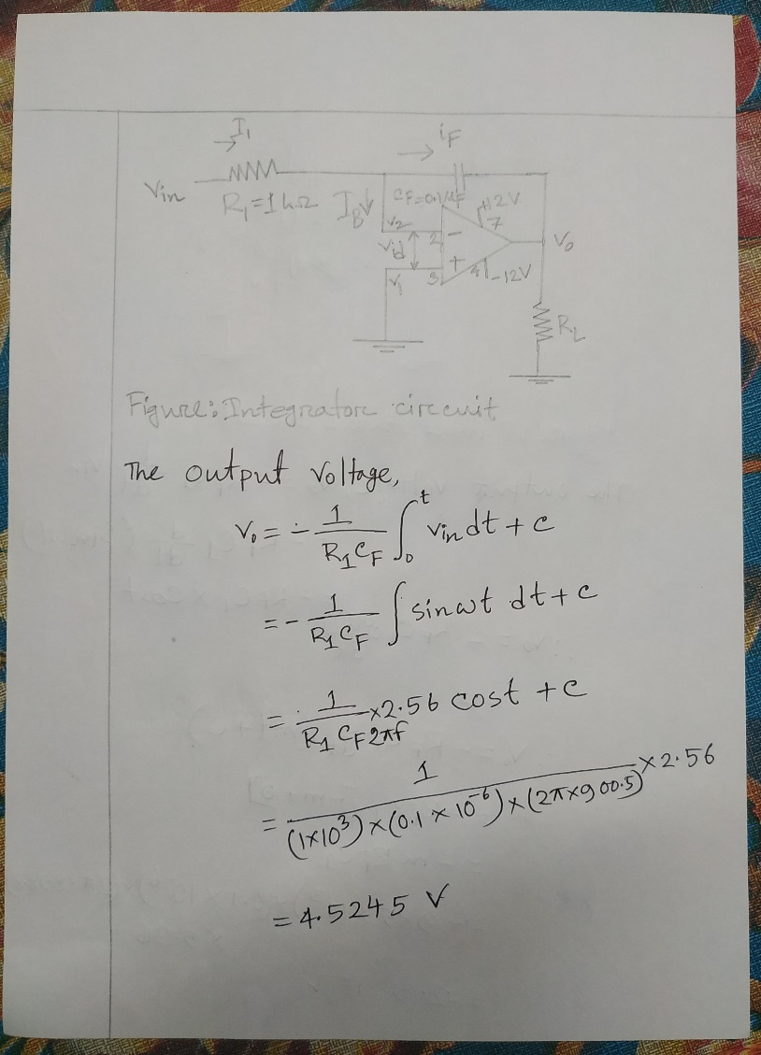

**Figure-1: Integrator Amplifier**

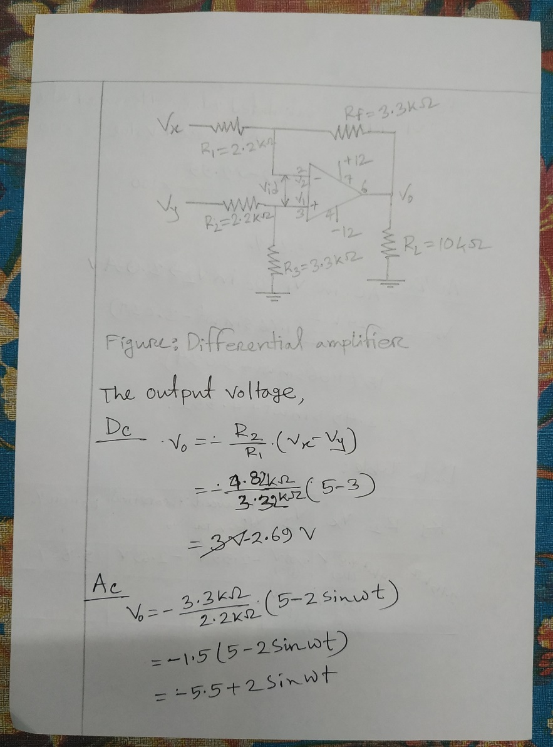

**Figure-2: Differential Amplifier**

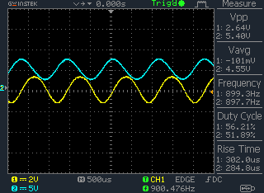

**Figure-4.1: Integrator Amplifier output wave**

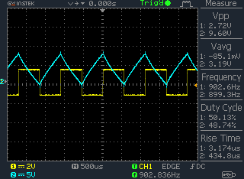

**Figure-4.2: Integrator Amplifier output wave**

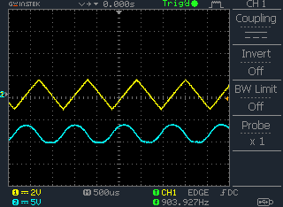

**Figure-4.3: Integrator Amplifier output wave**

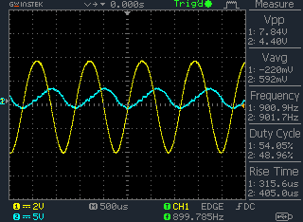

**Figure-5.1: Differential Amplifier output wave**

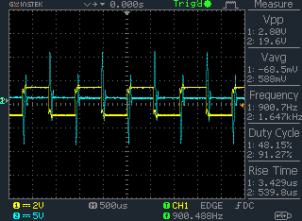

**Figure-5.2: Differential Amplifier output wave**

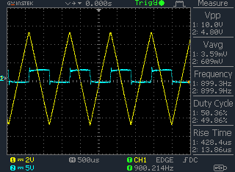

**Figure-5.3: Differential Amplifier output wave**

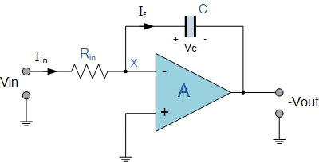**Answer: 01**

Op-amp Integrator Circuit

As its name implies, the **Op-amp Integrator** is an operational amplifier circuit that performs the mathematical operation of **Integration**, that is we can cause the output to respond to changes in the input voltage over time as the op-amp integrator produces an output voltage which is proportional to the integral of the input voltage.

### The RC Integrator

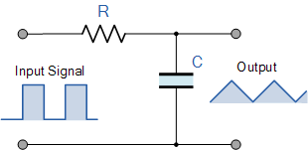

From which we derive an ideal voltage output for the integrator as:

integrator equation

### The RC Differentiator

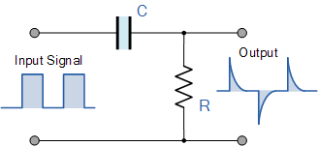

from which we have an ideal voltage output for the Differentiator as:

differentiator equation

### The AC Op-amp Integrator with DC Gain Control

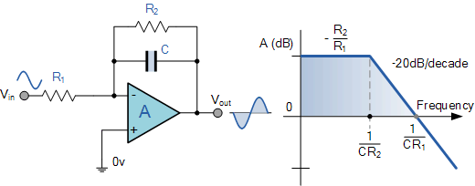

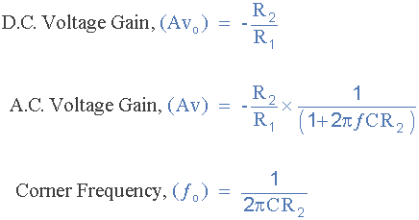

**Answer:02**

If we apply a constantly changing signal such as a Square-wave, Triangular or Sine-wave type signal to the input of a differentiator amplifier circuit the resultant output signal will be changed and whose final shape is dependent upon the RC time constant of the Resistor/Capacitor combination.

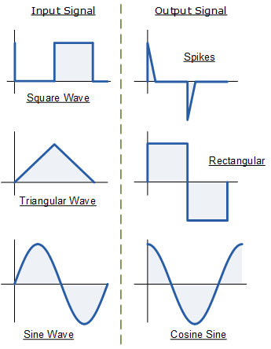Op-amp Differentiator Waveforms

**Answer:03**

Spike output wave shape is generated for rectangular input of differentiator

circuit is explaining below-

Op-Amp Differentiator Circuit

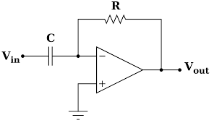

Op Amp Differentiator

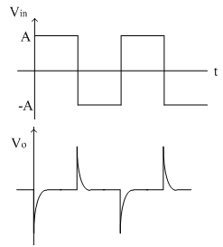

Output Waveforms

As amplitude V is constant, Vout =0

To simplify, Assume C1Rf = 1

But coming to the practical scenario, the output is not zero because the step wave takes time to rise from 0 to Vm volts.

At t= o, the output appears like a spike

When an input is given as a square wave, the output waveform will contain positive and negative spikes implies in the charging and discharging of a capacitor.

**Discussion:**

An integrator is an electronic circuit that produces an output that is the integration of the applied input. A differentiator is an electronic circuit that produces an output equal to the first derivative of its input.

In this experiment, I learned about the Op-amp IC and its characteristics. I also learned about the working of the Op-amp IC. we learn about integrator and differentiator circuit(µ-741) working principle. I performed an experiment by using an Op-Amp IC, capacitor and resistor and connect a DC/AC power supply to the circuit and verify both the Integrator and Differentiator circuit conditions of the Op-Amp IC and got the desired result. The main fucus of this experiment integrator and differentiator circuit work and six different output wave shapes on oscilloscope display.

## Experiment no: 03

**Name of the Experiments: Demonstration on Closed-loop Summing Amplifier.**

## Objective:

This experiment is intended to observe the operation of Op-Amp IC as Summing Amplifier.

## Theory:

**Summing Amplifier**: The summing amplifier can be build using two op-amp configurations: Inverting and Non-inverting.

## Inverting configuration:

*IF*



*R Ia*

*a*

*va  v2*

*RF*

*+12*

*7*

*vb Rb*

*Ib vid*

*2 741*

*3*

*6 vo=-RF(va/Ra+vb/Rb+vc/Rc)*

*v1*

*Rc Ic*

*v*

*c*

*4*

*-12 RL*

*ROM=Ra*⬅⬇*Rb*⬅⬇*Rc*⬅⬇*RF*

Figure 3.1: Inverting three input summing amplifier

Figure 3.1 shows the inverting configuration with three inputs *va, vb, vc*. Since *Ri* and *A* of the op- amp are ideally infinity, I2=0 A and *v*1  *v*2  0

Applying KCL, we get

*Ia*  *Ib*  *Ic*  *IF* . If in the circuit *Ra*  *Rb*  *Rc*  *R* , then the output

voltage equation can be written as *v*

  *RF* *v*

* *v*  *v* 

## Non-inverting amplifier:

*o R a b c*

*v2*

*R1 vid*

*RF*

*+12*



*7*

*2 741*

*6 vo*  1 *RF*  *va*  *vb*  *vc*

*v1 3*

*4*

 *R*  3

*va R*



*-12*

 1 

*RL*

*vb R*

*R*

*vc*

**Figure 3.2: Non-inverting three input summing amplifier**

If the voltage sources and the resistors are connected to the non-inverting terminal as shown in figure 3.2, the circuit can be used as summing amplifier. By applying Super Position theorem at the input section we get,

*v*  *va*  *vb*  *vc*

Hence the output voltage *v*

is *v*

 1 *RF*  *v*

1 3 *o*

*o*  *R*  1

And

*v*  1 *RF*  *va*  *vb*  *vc*

 1 

*o*  *R*  3

 1 

## Circuit Diagram for the Experiment:

*Va R1=2.2k*



*RF=2.2k*

*+12V*

*7*

*R=2.2k*

*3*

*2 741*

*6 vo*

*R=2.2k*

*4*

*-12V*

*V*

*RF=2.2k*

*+12V 7*



*2 741 6 vo*

*3*

*a*

*Vb*

*Vb RL=10k*

*R=2.2k* *R=2.2k*

*4*

*-12V*

*RL=10k*

Figure- 3.3: Two input (i) inverting & (ii) non-inverting summing amplifier.

## Procedure:

1. Build the circuit as shown in figure 3.3(i) on the trainer board.
2. Determine the gain AF of the inverting configuration.
3. Take input signals from the DC power supply and Function Generator as per the data table given below.
4. Determine the out-put voltage, *vo* using digital multimeter/ oscilloscope.
5. Determine the out-put current, *Io* by applying Ohm’s Law.
6. Calculate the theoretical output voltage.
7. Calculate the % of error for *vo* using the formula-

% of error  *CalculatedValue* ~ *MeasuredValue* 100%

*MeasuredValue*

1. Now, build the circuit as shown in figure 3.3(ii) on the trainer board.
2. Determine the gain AF of the non-inverting configuration.
3. Repeat the procedure 3-7.
4. Complete the data table-3.1 given below

**Results:**

**Theoretical Calculation, Data Table, Figure:**

**P.T.O.**

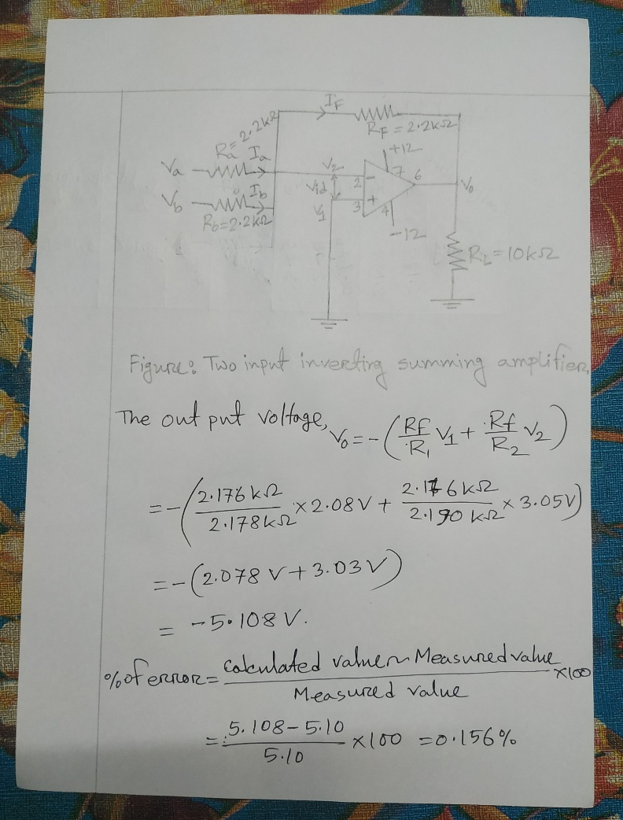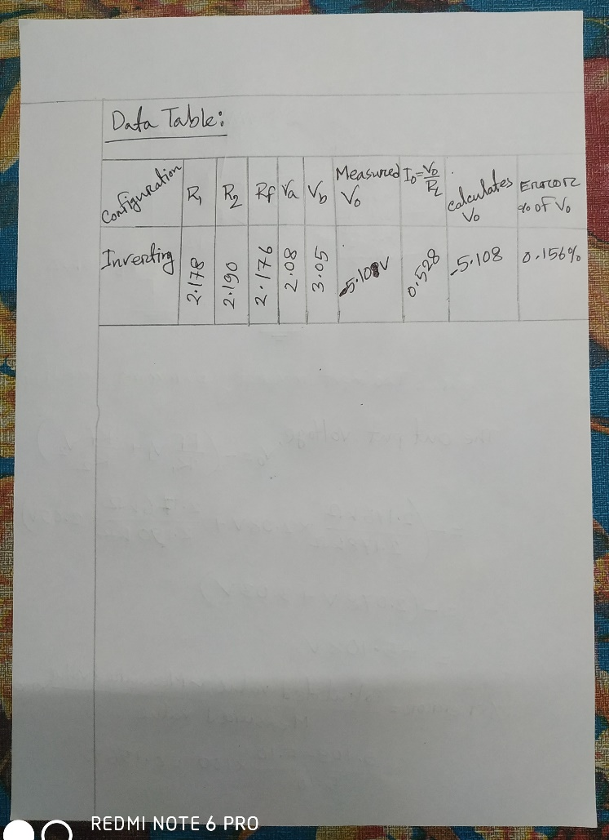

**Figure-1: summing Amplifier**

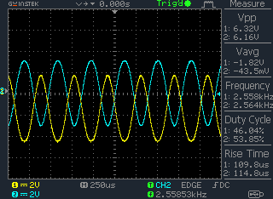

**Figure-2: summing Amplifier output wave**

**Answer:01**

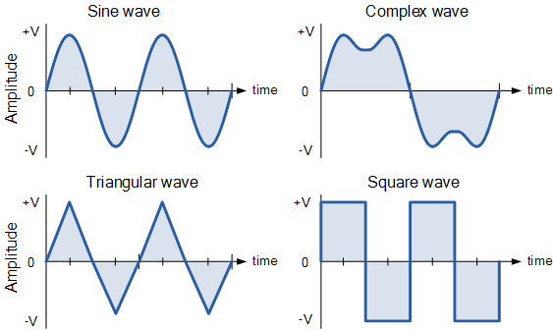

Types of Periodic Waveform

The time taken for an **AC Waveform** to complete one full pattern from its positive half to its negative half and back to its zero baseline again is called a **Cycle** and one complete cycle contains both a positive half-cycle and a negative half-cycle.

**Discussion:**

The Summing Amplifier is another type of operational amplifier circuit configuration that is used to combine the voltages present on two or more inputs into a single output voltage. We saw previously in the inverting operational amplifier that the inverting amplifier has a single input voltage, (Vin) applied to the inverting input terminal. If we add more input resistors to the input, each equal in value to the original input resistor, (Rin) we end up with another operational amplifier circuit called a Summing Amplifier.

In this experiment, I learned about the working of the Op-amp IC. I performed an experiment by using an Op-Amp IC, capacitor and resistor and connect a DC/AC power supply to the circuit and verify summing circuit conditions of the Op-Amp IC and got the desired result. I also learned about the working of the Summing Amplifier. Then all is perfect we collect result for data table.

## Experiment no: 04

**Name of the Experiments: Demonstration on Closed-loop Differential Amplifier.**

## Objective:

This experiment is intended to observe the operation of Op-Amp IC as Differential Amplifier.

**Theory:** Figure 4.1 shows the differential amplifier with one op-amp. A differential amplifier is a combination of inverting amplifier and non-inverting amplifiers. That is, when *vx* is reduced to zero the circuit is a non-inverting amplifier, whereas the circuit is an inverting amplifier when the *vy* is reduced to zero.

The output voltage due to *vx* is *vox*

 *RF vx*

*R*1

The output voltage due to *v* is *v*

 (1 *RF* )*v* and *v* 

*R*3*vy*

*x oy*

*R* 1 1

*R*  *R*

Since *R*  *R*

and *R*

 *R* , *v*

 *RF vy*

1 2 1

1 2 3

*F oy*

1

Thus the net output voltage is, *v*  *v*  *v*

*R*

 *RF* (*v*  *v* )  *RF v*

*o ox oy R x y R xy*

1 1

And the voltage gain *A*  *vo*   *RF*

*D v R*

*x* 1

## Circuit Diagram:

*vx*



*R1=2.2 k* *RF=3.3 k*

*+12*

*vid*

*vy*

*R2=2.2 k*

*2*

*v2*

*v1* 

*3*

***741***

*7*

*4*

*-12*

*6 vo=AD.vxy*

*RL=10K*

*R3=3.3 k*

Figure 4.1: Differential amplifier

## Procedure:

1. Build the circuit as shown in figure 4.1 on the trainer board.
2. Determine the gain AF.
3. Take input signals from the DC power supply and Function Generator as per the data table given below.
4. Measure the output voltage, Vo by the digital multimeter/ oscilloscope.
5. Calculate the theoretical output voltage, *vo* .
6. Determine the out-put current, *Io* by applying Ohm’s Law.
7. Calculate the % of error for *vo* using the formula-

% of error  *CalculatedValue* ~ *MeasuredValue* 100%

*MeasuredValue*

1. Complete the data table- 4.1 given below.

**Results:**

**Theoretical Calculation, Data Table, Figure:**

**Figure-1: Differential Amplifier**

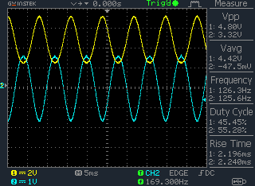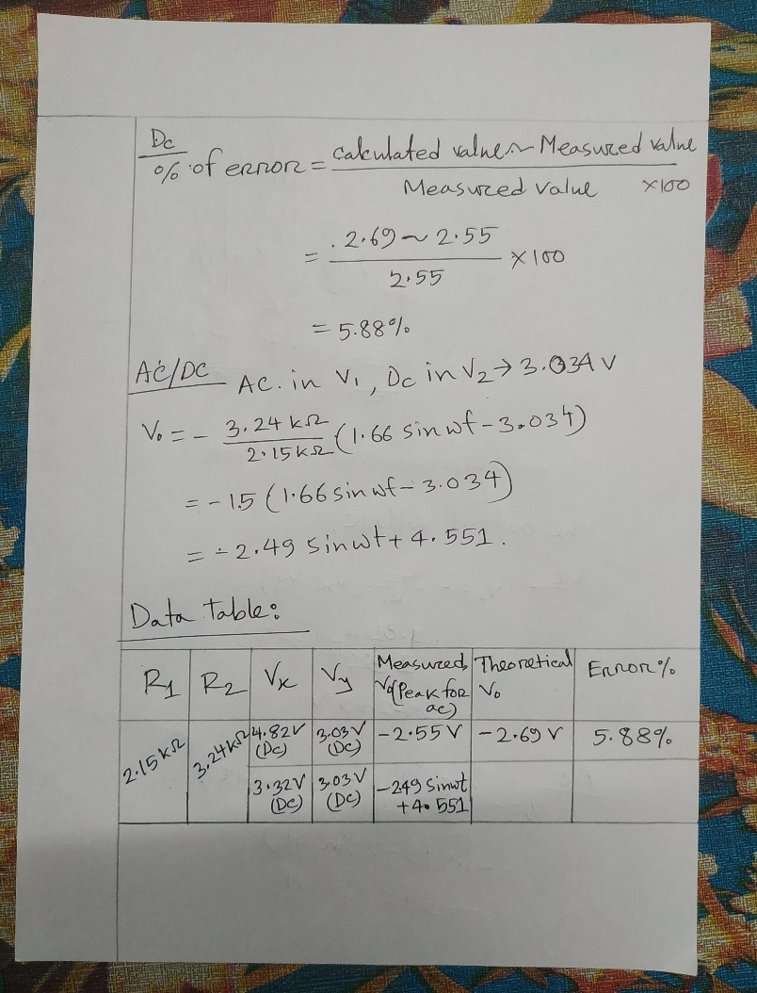

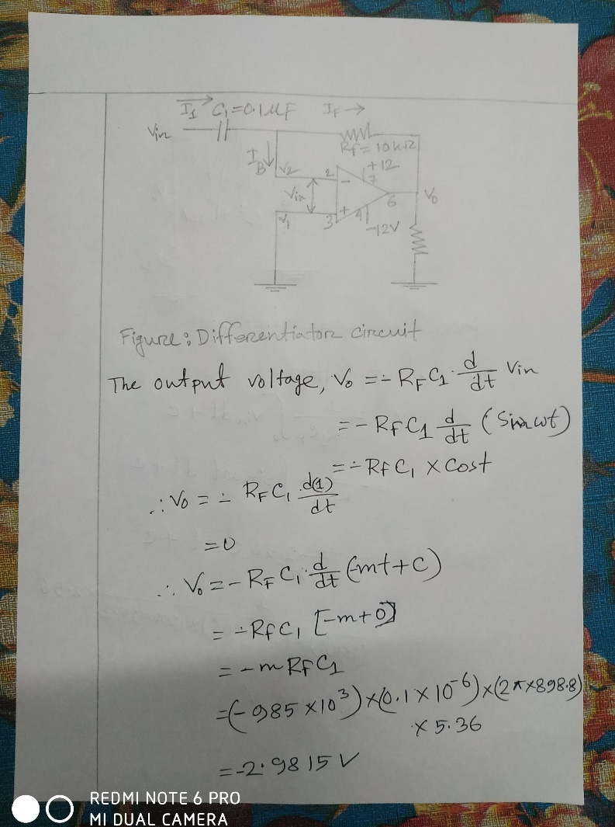

**Figure-2: Differential Amplifier Output Wave**

**Answer:01**

The input and output wave shape that we observed for AC different input:



**Answer:02**

Designing a circuit whose output is VO= 3×(E1- E2)

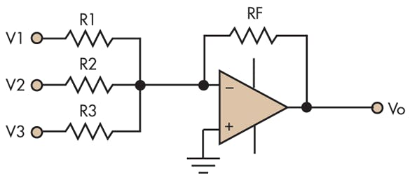

**Discussion:**

The differential amplifier is a voltage subtractor circuit which produces an output voltage proportional to the voltage difference of two input signals applied to the inputs of the inverting and non-inverting terminals of an operational amplifier. The current mirror is usually used in combination with the differential amplifier to affect the bias so that the transistors operate inactive mode.

In this experiment, I learned about the Op-amp IC and its characteristics. I also learned about the working of the Differential Amplifier. I also learned about the Inverting and Non-inverting circuit conditions of the Op-Amp IC. Because a differential amplifier is a combination of inverting amplifiers and non-inverting amplifiers. I learned about the interior of the Op-Amp. In this lab, I performed an experiment by using an Op-Amp IC, capacitor, and resistor and connect a power supply to the circuit and verify the Differential Amplifier circuit conditions of the Op-Amp IC and got the desired result. Now I'm fully able to do these kinds of experiments.

## Experiment no: 05

**Name of the Experiment: Demonstration on Low-Pass Filter Circuits.**

## Objective:

The aim of this experiment is to observe the basic characteristics of low-pass filter.

**Theory:** Figure 5.1 shows a first-order low-pass Butterworth filter that uses an RC network for filtering. The op-amp is used in the non-inverting configuration.

*R1 RF*



*+12*

*v2 7*

*v 2 741 6 v*

 *R C d v*

*vin*

*R*

*v1 id 3*

*C*

*4*

*-12*

*o F* 1 *dt in*

*RL*

Figure 5.1 First-order low-pass Butterworth filter

According to the voltage divider rule, the voltage at the non-inverting terminal (across capacitor C)

is, *v* 

* *jXC v*

or, *v* 

*vin*

1 *R*  *jX in* 1 1 *j*2 *fRC*

*C*

The output voltage

*v*  1 *RF*  *v*

or, *v*  1 *RF* 

*vin*

*o*  *R*  1

*o*  

1 *RF* 

 1 

 *R*1  1 *j*2 *fRC*

*v*  *R*  *A A*

*o*   1   *F*  *F*

*vin*

1 *j*2 *fRC*

1 *j*2 *fRC*

1 *j*( *f* / *fH* )

Gain of the filter as a function of frequency

*A* ( *f* )  *vo F v*

 *AF*

1 *j*( *f* / *f* )

Where, *f* = *frequency of the input signal*

*in H*

*A*  1 *RF*

*F*

*R*1

 *passband gain of the filter*

*fH* 

1

2 *RC*

*vo vin*

1 ( *f* / *f*

*H*

)2

*A*

 *high cutoff frequency of the filter*

The magnitude of the voltage gain is

## Circuit Diagram:

*AF* ( *f* )   *F*

*vo*



*RF=1 k*

*R1=1 k*

*v*

*in*

*R= 2.2 k*

*+12V*

*7*

*2 741*

*3*

*4*

*-12V C=0.1**f*

*6*

*RL=10 k*

Figure -5.2: A practical first order low-pass Butterworth filter

## Instructions:

1. Determine the gain *AF* (in db) and the corner frequency *fH*.
2. Calibrate the oscilloscope and adjust the input signals amplitude and frequency.
3. Vary the frequency of the input signal keeping *vin(peak-peak)* fixed at 1V and take the value of *vo(peak-peak)* from the oscilloscope.
4. Change the frequency and complete the data table given below.
5. Draw the frequency response curve for this filter using semi-log paper.

**Results:**

**Theoretical Calculation, Data Table, Figure:**

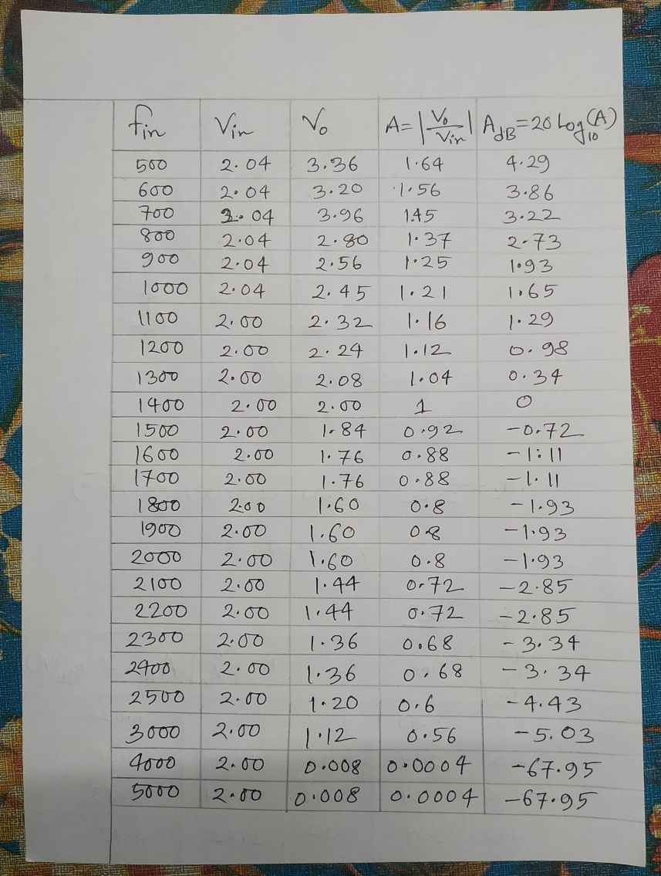

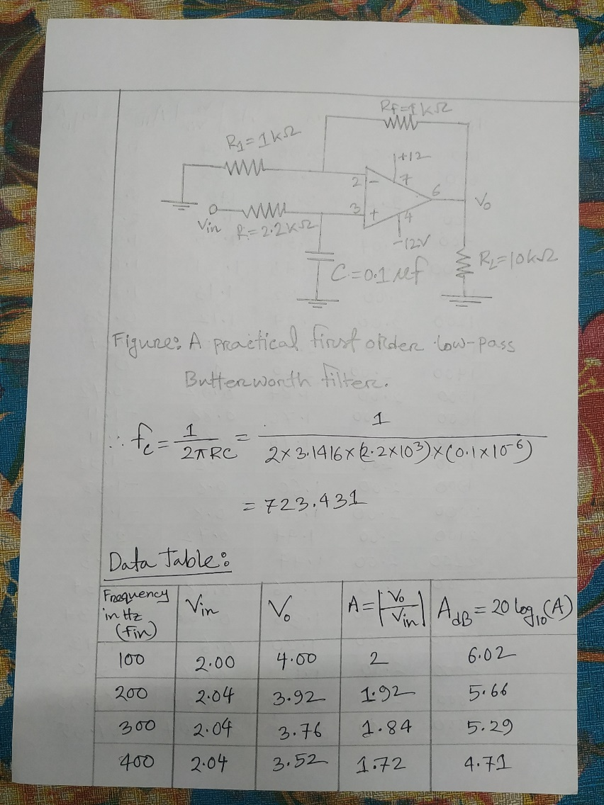

**Figure-1: Low-Pass Filter Circuits**

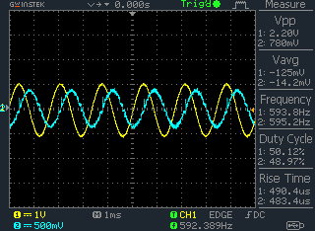

**Figure-2: Low-Pass Filter Circuits Output Wave**

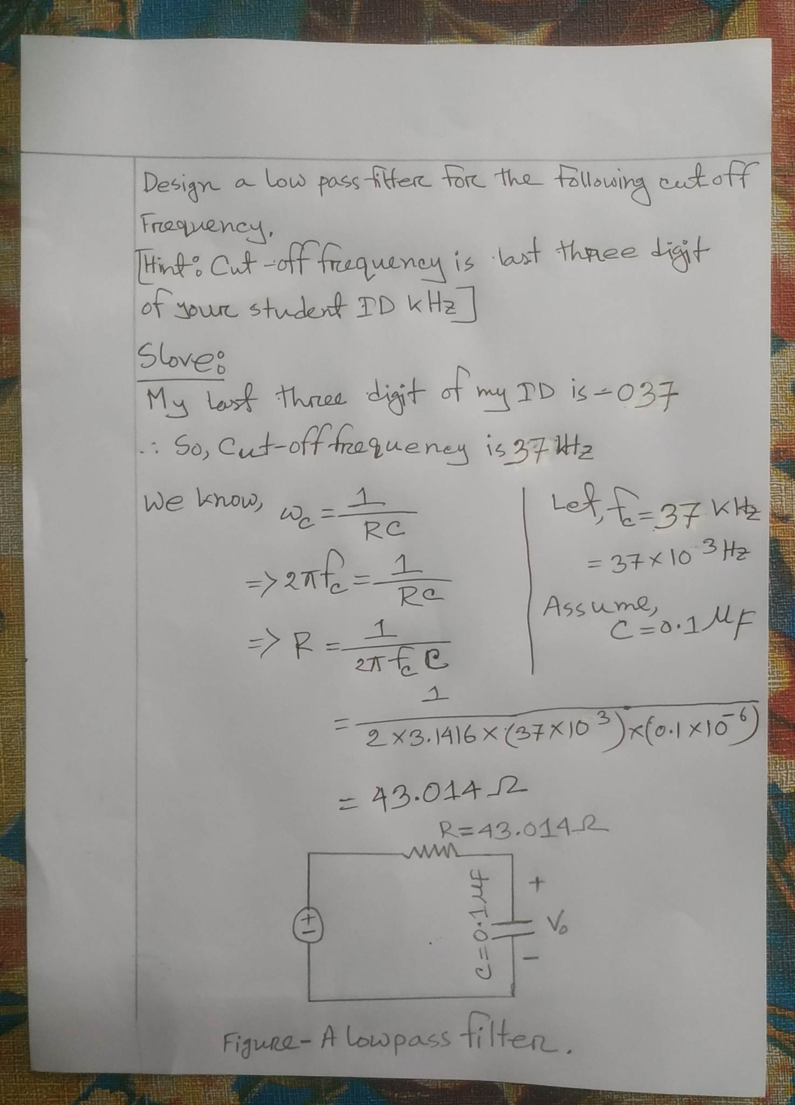**Answer-02:**

**Discussion:**

The filter circuit which allows only low pass frequency [components](https://www.watelectronics.com/major-electrical-electronic-components/) and blocks all other higher frequency components is called a low pass filter. The name LPF itself indicates low range frequency. At the cut-off frequency, the capacitive reactance of capacitor C is equal to the resistance of resistor R, causing the output voltage to be 0.707 times the input voltage (-3 dB).

In this experiment, I learned about the Op-amp IC and its characteristics. I also learned about the basic characteristics of low-pass filters. I performed an experiment by using an Op-Amp IC, capacitor, and resistor and connect a power supply to the circuit and verify the low-pass filter circuit conditions of the Op-Amp IC, and got the desired result. In case of low pass filter, we observe that for frequencies lower than cutoff gain magnitude is closer to 1. Now I'm fully able to do these kinds of experiments.

## Experiment no: 06

**Name of the Experiment: Demonstration on High-Pass Filter Circuits**

## Objective:

To observe the basic characteristics of high-pass filter.

## Theory:

Figure 6.1 shows a first-order high-pass Butterworth filter that uses an RC network for filtering. The op-amp is used in the non-inverting configuration.

According to the voltage divider rule, the voltage at the non-inverting terminal (across resistor R)

is, *v*1 

*R*

*R*  *jXC*

*vin*

Or, *v*

 *j*2 *fRC v*

and the output voltage *v*

 1 *RF*  *v*

1 1 *j*2 *fRC in*

*o*  *R*  1

That is, *v*

 1 *RF*  *j*2 *fRC v*

 1 

*o*   *in*

 *R*1  1 *j*2 *fRC*

*vo vin*

 *j*2 *fRC*.*AF*

1 *j*2 *fRC*

 *j*( *f* / *fL* ) *AF*

1 *j*( *f* / *fL* )

Gain of the filter as a function of frequency

*A* ( *f* )  *vo* 

*j*( *f* / *fL* ) *AF*

*F v* 1 *j*( *f* / *f* )

Where, *f* = *frequency of the input signal*

*in L*

*A*  1 *RF*

*F*

*R*1

 *passband gain of the filter*

*fL* 

1

2 *RC*

*vo vin*

( *f* / *fL* ) *AF*

1 ( *f* / *f* )2

*L*

 *low cutoff frequency of the filter*

The magnitude of the voltage gain is

*AF* ( *f* )

## Instructions:

1. Determine the gain *AF* and the corner frequency *fL*.
2. Calibrate the oscilloscope and adjust the input signals amplitude and frequency.
3. Vary the frequency of the input signal keeping *vin(peak-peak)* fixed and take the value of

*vo(peak-peak)* from the oscilloscope.

1. Complete the data table given below.
2. Draw the frequency response curve for this filter using semi-log paper.

**Results:**

**Theoretical Calculation, Data Table, Figure:**

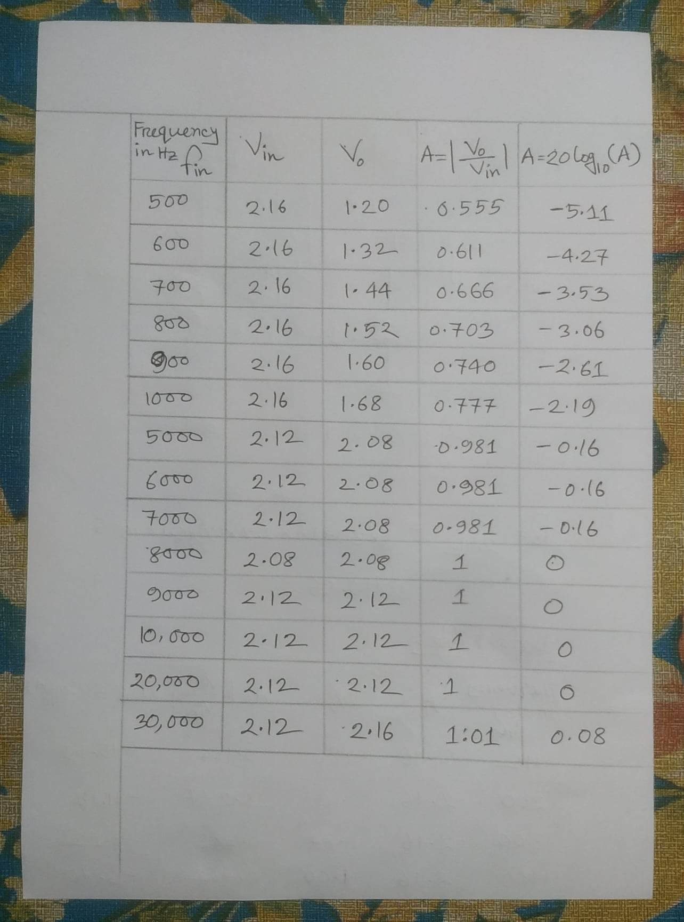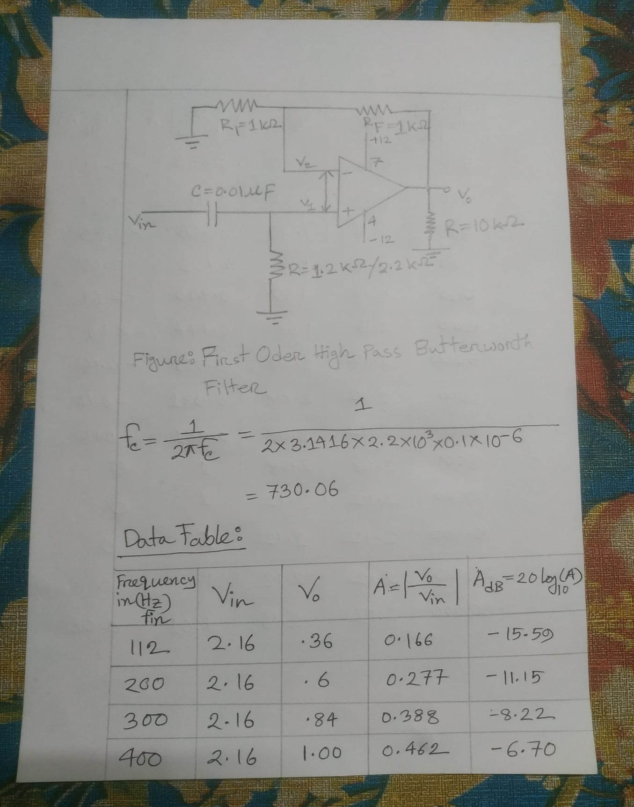

**Figure-1: High-Pass Filter Circuit**



**Figure-2: High-Pass Filter Circuits Output Wave**

**Asnwer-02:**

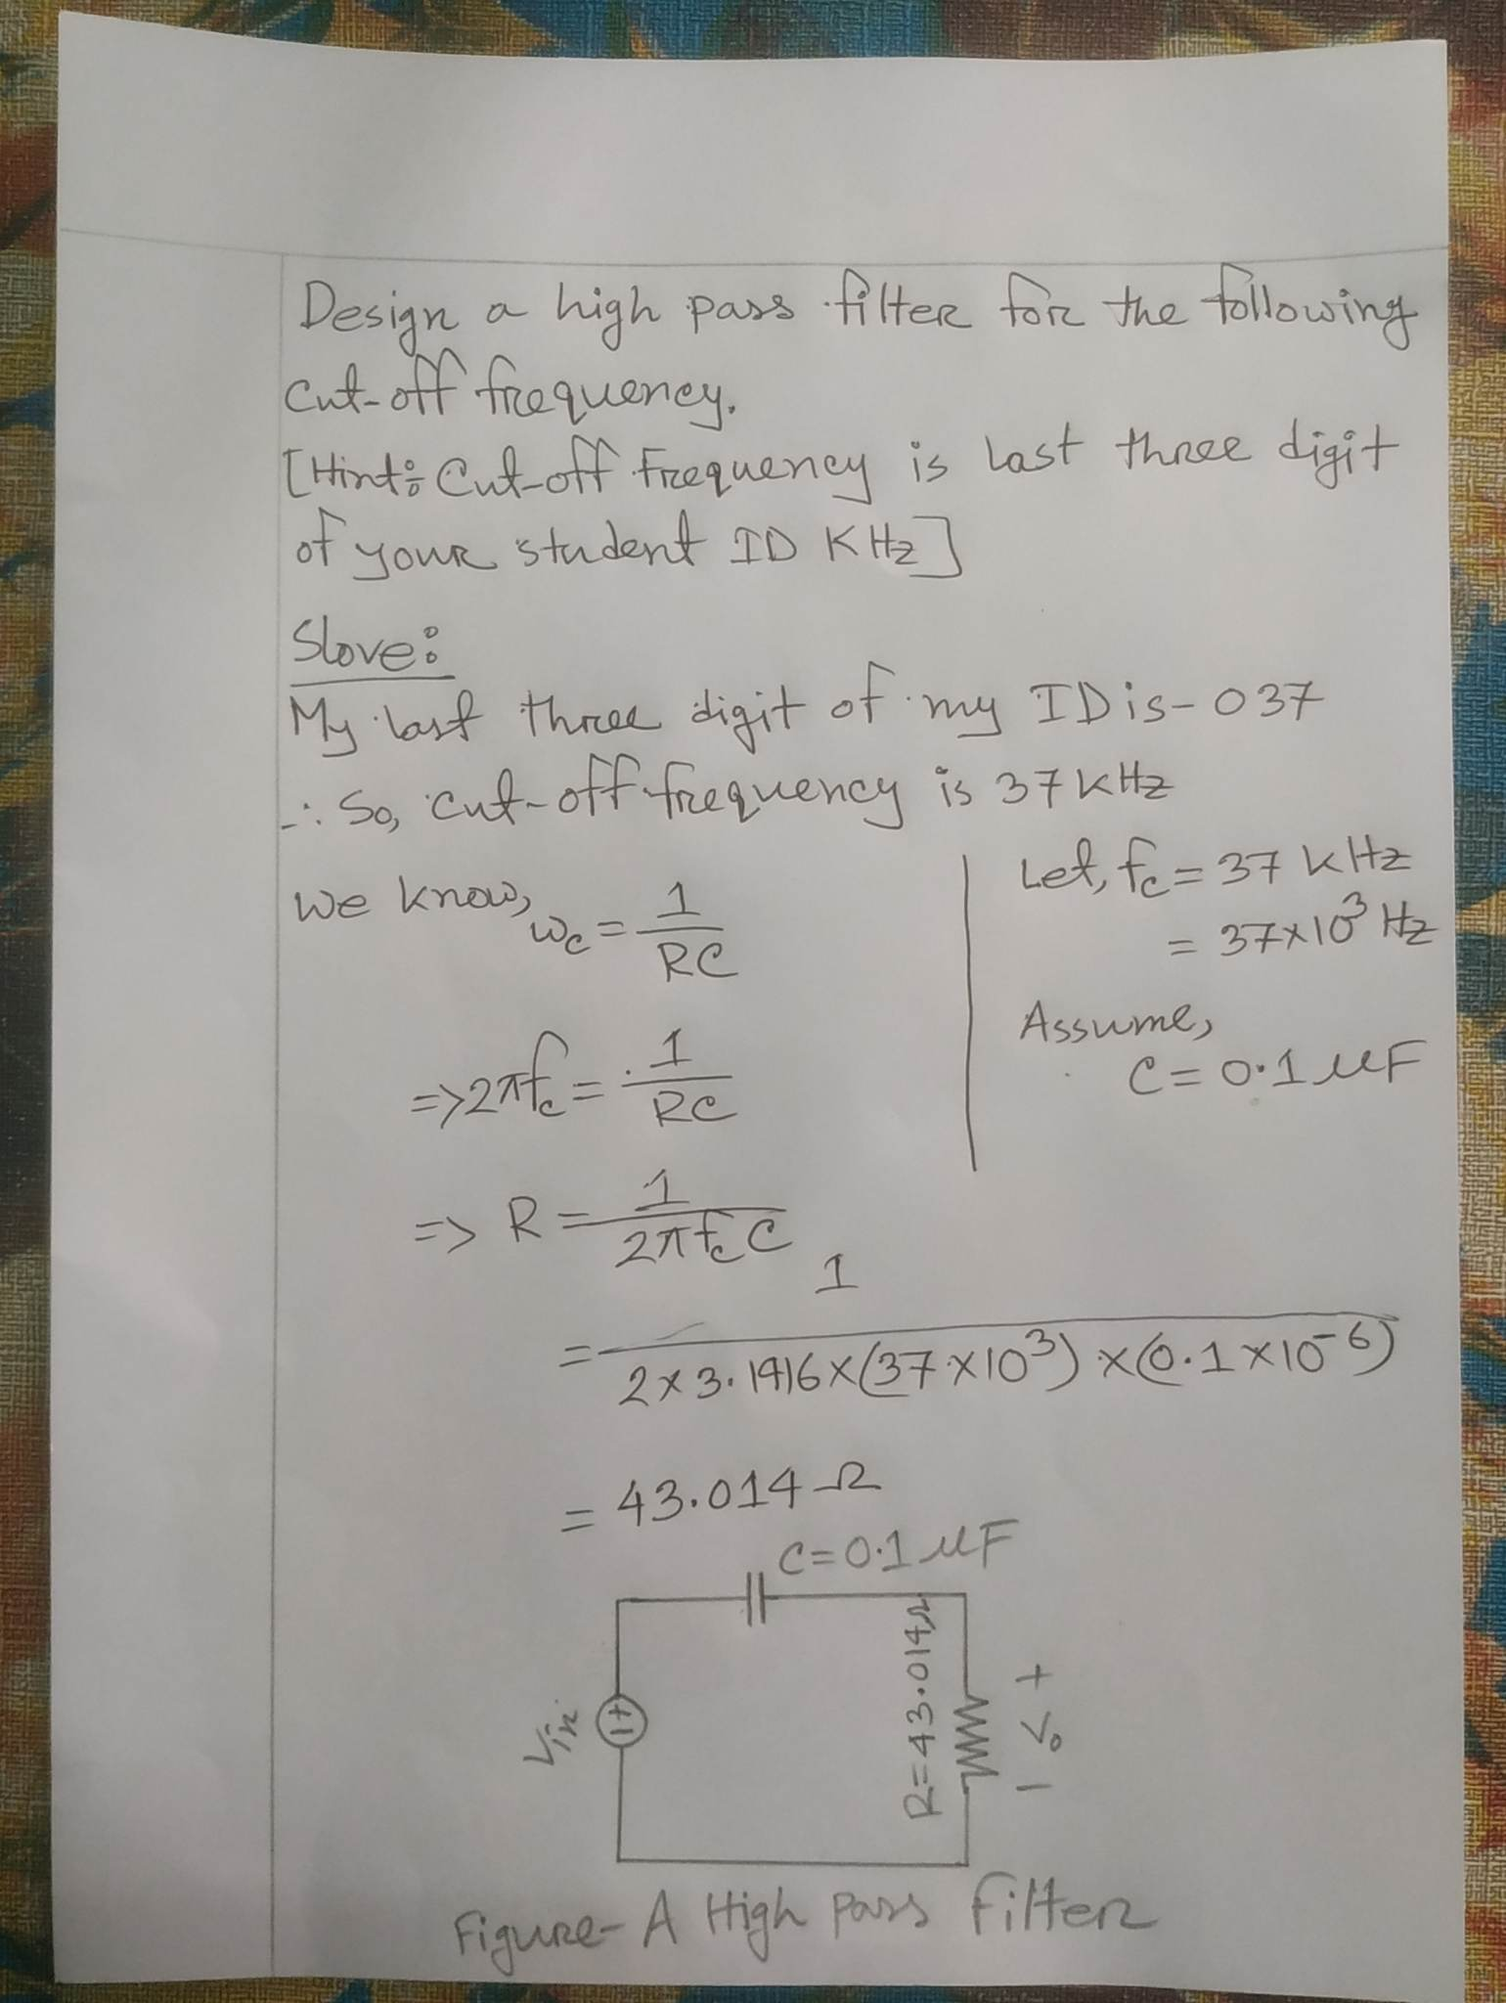

**Discussion:**

**The definition of high pass filter** is a filter which passes only those signals whose frequencies are higher than cutoff frequencies thereby attenuating signals of lower frequencies. The value of cutoff frequency depends on the design of the filter. The slope of high pass filter curve is +20 d B/ decade after passing cutoff frequency level the output response of the circuit increases from 0 to Vin at a rate of +20 dB per decade which is 6 dB increase per octave.

In this experiment, I learned about the basic characteristics of High-pass filters. I also learned about the non-inverting circuit conditions of the Op-Amp IC. Because The op-amp is used in the non-inverting configuration. I learned about the interior of the Op-Amp. In this lab, I performed an experiment by using an Op-Amp IC, capacitor, and resistor and connect a power supply to the circuit and verify the High-pass filter circuit conditions of the Op-Amp IC, and got the desired result. Now I'm fully able to do these kinds of experiments.